Whose Land is It?
After Christopher Columbus got lost looking for India he “discovered” Turtle Island (what is now North America) which was plentiful in fur bearing animals. As the popularity of furs hit Europe the fur trade began to boom. Hundreds and thousands of Europeans headed to Turtle Island. They began to colonize as European nations did at that time, and King’s overseas signed permission for their colonies to access lands in the new found area.
King Charles the II of England with the advice from his nephew Prince Rupert signed over a large chunk of land to a privately owned Hudson Bay Company in 1670. (see map below)
The dispute over land on Turtle Island caused conflict between the two major European players, England and France. This resulted in the Seven Year War from 1756-1763 between the two nations both between the colonies here and in Europe. The British were the victors in the war and their Indian allies played a big part in the Battles on Turtle Island. At the same time the 13 Colonies (Now the USA) was at war with the British who they were a colony of as well. The British wanted to stabilize their borders from the French and the 13 Colonies. They knew that the aid of the Indians would help. King George III of England signed the Royal Proclamation of 1763, that stated “All land belonged to the Indians unless sold or ceded by Treaty”.
In 1811 the HBC granted Thomas Douglas the Earl of Selkirk 300,000 square km of land in what’s now southern Manitoba in the Red River Valley area. The land was previously part of Rupert’s Land. The new settlement was supposed to use the fertile land for agriculture, that would feed workers of the HBC in the North at trading posts. However, there were already Metis and Indians settled in the area. Many of the Metis were involved in hunting the Buffalo and the pemmican trade. Following The Battle of Seven Oaks the new settlers from the HBC would leave and the Metis would be left behind in the Red River Settlement and continue with the Buffalo hunt and trading of Pemmican. (see map below)
In 1867 Canada was formed of New Brunswick, Nova Scotia, Quebec, and Ontario. This new country was looking to spread west towards the prairies. In 1869 HBC was transferring Rupert’s land over to the Dominion of Canada. The Metis feared that their land and culture would be taken away by the Canadian Government. The Red River Resistance followed and the Manitoba Act was a result in 1870. Metis Scrip was an article covered under Article 31 of the Manitoba Act which promised the Metis 1.4 million acres of land in Southern Manitoba.
As we know the First Nations in Manitoba signed Treaty 1 & 2 with the Canadian government in a year later in 1871, Treaty 3 in 1873. The areas covered in these Treaties are the same areas that were promised to the Metis in 1870.
Your assignment is to write an essay explaining who the rightful owners of Southern Manitoba. Use a graphic organizer to help you get organized. Keep in mind the potential tenants of this are: The Manitoba Metis who signed Scrip (1870), Indians who signed Treaty 1 & 2 (1871), Government. Answer why the group you chose is entitled to the land, provide some back up from research to support your groups claim and include other groups potential claims.

Rupert’s Land
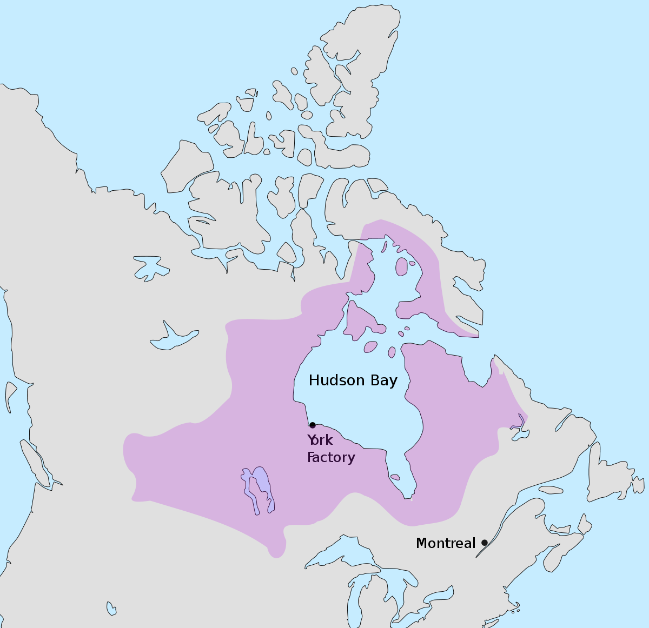

Selkirk Settlement Map
